DECLARATION
I, [Manoj.C], bearing Register Number [25508874], hereby declare that this project report titled "Design and Configuration of a Secure Banking Network (SecureBank)" is my own original work, carried out using Cisco Packet Tracer, and has not been submitted elsewhere for the award of any degree or diploma.
Place: [Mylapore]
Date: [ ]
Signature of Student

ACKNOWLEDGEMENT
I take this opportunity to express my sincere gratitude to [Sugumaran.M], Principal, [Ramakrishna Mission Polytechnic College], for granting permission and extending the necessary facilities for this project.
I am deeply thankful to [Dhilipkumaar.D], Head of the Department of Computer Engineering, and my Faculty Guide, [Mugundhan.M], for their continuous guidance, valuable suggestions and encouragement throughout the design and implementation of this network.
I also thank my parents, friends and classmates for their constant support and encouragement throughout this project.

TABLE OF CONTENTS
Chapter 1 — Introduction 1
Chapter 2 — Project Overview 3
Chapter 3 — Network Design 5
Chapter 4 — Configuration Procedure 7
Chapter 5 — Testing, Screenshots & Results 10
Chapter 6 — Challenges & Learning Outcomes 14
Chapter 7 — Conclusion & Future Scope 15
References 16

LIST OF FIGURES
Fig 1 — Overall Network Topology (Head Office, Branch 1 & Branch 2) 6
Fig 2 — Static IP Configuration at Branch 1 (BR1-PC1) 9
Fig 3 — Static IP Configuration at Branch 2 (PC7) 10
Fig 4 — DNS Server IP Configuration (DNS-Server) 8
Fig 5 — DNS Resource Record Configuration (A Record — www.banking.local) 8
Fig 6 — FTP Server IP Configuration (FTP-server) 9
Fig 7 — Mail Service Verification (POP3 Mail Browser) 11
Fig 8 — Web Service Verification (Secure Bank Portal) 12
Fig 9 — FTP Service Verification from Branch 2 (PC7 Command Line) 13

CHAPTER 1: INTRODUCTION

1.1 Introduction to the Project
Modern banking institutions operate across a Head Office and multiple Branch Offices that must remain securely and reliably interconnected at all times. Employees need access to shared services such as email, internal websites, file transfer and centralized logging, regardless of which branch they work from. This project, titled "SecureBank," simulates such a multi-site banking network using Cisco Packet Tracer, demonstrating how a Head Office and two Branch Offices can be interconnected and provided with essential enterprise network services.

1.2 Why Cisco Packet Tracer
Cisco Packet Tracer is a network simulation tool developed by Cisco Systems that allows learners to design, configure, and troubleshoot complete network topologies in a risk-free virtual environment. It supports routers, switches, end devices and application-layer servers (DNS, HTTP, Mail, FTP, Syslog), making it well suited to modelling a realistic banking network without needing physical hardware.

1.3 Objectives of the Project
- To design a three-site network consisting of a Head Office and two Branch Offices.
- To assign a structured, non-overlapping IP addressing scheme to each site.
- To interconnect the Head Office with both branches so that all sites can communicate.
- To host centralized DNS, Web, Mail, FTP and Syslog services at the Head Office.
- To configure and verify DNS name resolution and FTP file-transfer access from the branch offices.
- To verify that branch-office users can access the head-office web portal and exchange mail across sites.
- To document the design, configuration and testing process in a structured project report.

CHAPTER 2: PROJECT OVERVIEW

2.1 Project Title
Design and Configuration of a Secure Banking Network — "SecureBank" (Head Office & Branch Connectivity)

2.2 Problem Statement
A bank operates a Head Office along with two remote Branch Offices. Each site has its own local users and devices, but critical services — internal DNS resolution, the corporate website, staff email, file transfer and centralized system logging — are hosted only at the Head Office. The network must be designed so that users at every branch can reliably reach these Head-Office-hosted services, while each site's local network remains logically separated using its own IP subnet.

2.3 Scope of the Project
- Head Office (HQ) LAN with administrative PCs and a server farm.
- Branch 1 LAN with three end-user PCs.
- Branch 2 LAN with three end-user PCs.
- Point-to-point links from the Head Office router to each branch router.
- Centralized DNS, Web, Mail (POP3/SMTP), FTP and Syslog servers at the Head Office.
- End-to-end verification of connectivity, DNS resolution, web access, FTP access and mail exchange between sites.

2.4 Hardware / Devices Used (in Packet Tracer)
Device | Quantity | Role
Router (Router-PT) | 3 | Inter-site connectivity — R1-HQ, R2-BR1, Router2 (BR2)
Switch (Switch-PT) | 3 | Local LAN switching — SW1-HQ, SW2-BR1, Switch2
PC (PC-PT) | 10 | End-user workstations across HQ, Branch 1 and Branch 2
Server (Server-PT) | 5 | DNS, Web, Mail, FTP and Syslog services at HQ

2.5 Software Requirements
- Cisco Packet Tracer (network design and simulation)
- Microsoft Word (project documentation)

CHAPTER 3: NETWORK DESIGN

3.1 Network Topology
The network is built as a hub-and-spoke topology, with the Head Office router (R1-HQ) acting as the central hub connected by dedicated point-to-point links to the Branch 1 router (R2-BR1) and the Branch 2 router (Router2). Each site has its own switch aggregating local end devices, keeping every site's LAN traffic locally switched while inter-site traffic is routed through the Head Office.
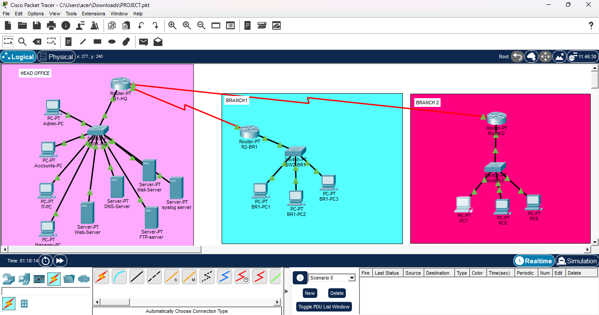
Fig 1 — Overall network topology — Head Office, Branch 1 and Branch 2

3.2 Site-wise Device Layout
Site | Router | Switch | End Devices
Head Office (HQ) | R1-HQ | SW1-HQ | Admin-PC, Accounts-PC, IT-PC, Manager-PC + Mail, DNS, Web, Syslog, FTP Servers
Branch 1 | R2-BR1 | SW2-BR1 | BR1-PC1, BR1-PC2, BR1-PC3
Branch 2 | Router2 | Switch2 | PC7, PC8, PC9

3.3 IP Addressing Table
Each site is assigned a distinct /24 subnet, keeping the addressing scheme simple, structured and easy to route between sites.
Site | Network | Sample Host | IP Address | Gateway
Head Office | 192.168.10.0/24 | Web Server | 192.168.10.3 | 192.168.10.1
Head Office | 192.168.10.0/24 | DNS Server | 192.168.10.2 | 192.168.10.1
Head Office | 192.168.10.0/24 | Mail (POP3) Server | 192.168.10.4 | 192.168.10.1
Head Office | 192.168.10.0/24 | FTP Server | 192.168.10.5 | 192.168.10.1
Branch 1 | 192.168.20.0/24 | BR1-PC1 | 192.168.20.10 | 192.168.20.1
Branch 2 | 192.168.30.0/24 | PC7 | 192.168.30.10 | 192.168.30.1

All end devices across the three sites are configured to use 192.168.10.2 (the Head-Office DNS server) as their DNS resolver, allowing every branch to resolve internal hostnames such as the SecureBank web portal (www.banking.local) centrally.

CHAPTER 4: CONFIGURATION PROCEDURE

4.1 Router & WAN Link Configuration
R1-HQ was configured with two point-to-point links — one to R2-BR1 and one to Router2 — establishing a hub-and-spoke WAN. Appropriate routing (static or dynamic, as per the routing table on each router) was configured so that every subnet — Head Office, Branch 1 and Branch 2 — is reachable from every other site.

4.2 Switch Configuration
SW1-HQ, SW2-BR1 and Switch2 operate as access-layer switches, connecting all local PCs and, at the Head Office, the server farm, to their respective site router. All ports were left in their default access-switching mode, since each site uses a single flat LAN.

4.3 End-Device (PC) Configuration
Every PC at every site was assigned a static IPv4 address, subnet mask, default gateway and DNS server through the Desktop → IP Configuration utility in Packet Tracer, rather than relying on DHCP, giving predictable and easily verifiable addressing across the whole bank network.
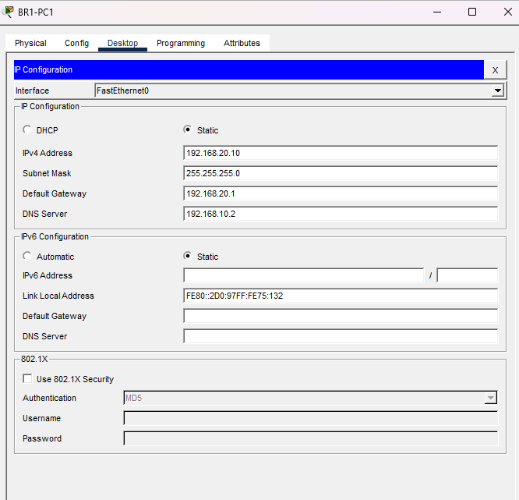
Fig 2 — Static IP configuration on BR1-PC1 (Branch 1) — 192.168.20.10 /24, gateway 192.168.20.1, DNS 192.168.10.2

4.4 Server Configuration (Head Office)
Server | Service Configured | Purpose
DNS-Server | DNS | Resolves internal hostnames (e.g. the SecureBank portal) for all sites
Web-Server | HTTP | Hosts the internal "SecureBank" banking portal page
Mail-Server | POP3 / SMTP | Provides staff email accounts (e.g. br1pc1@banking.com)
FTP-server | FTP | Centralized file transfer / storage for HQ and branch staff
syslog server | Syslog | Centralized logging of network device events

4.4.1 DNS Server Configuration
The DNS-Server was assigned the static IP address 192.168.10.2 /24 with default gateway 192.168.10.1, as shown in Fig 4. Under Services → DNS, an A-record was created mapping the hostname www.banking.local to the Web-Server address 192.168.10.3, so that all branch users can reach the SecureBank portal by name instead of by IP address.
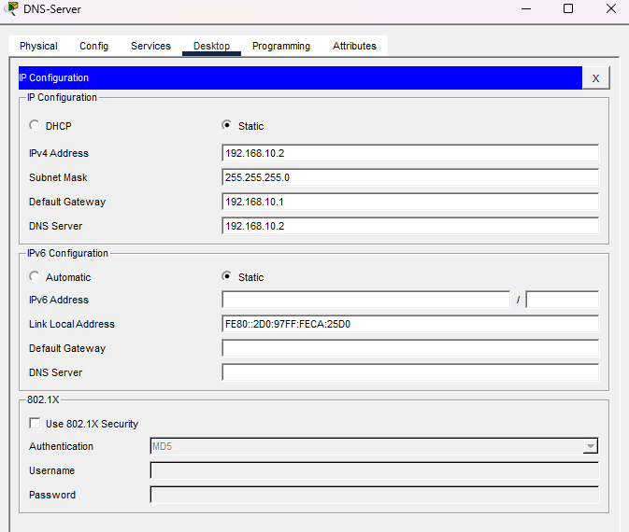
Fig 4 — DNS-Server IP configuration — 192.168.10.2 /24, gateway 192.168.10.1
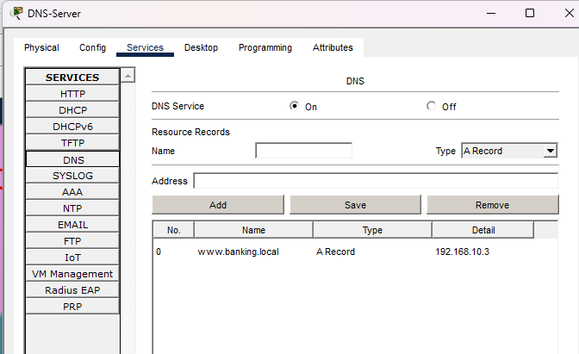
Fig 5 — DNS resource record configuration — A record: www.banking.local → 192.168.10.3

4.4.2 FTP Server Configuration
The FTP-server was assigned the static IP address 192.168.10.5 /24, with default gateway 192.168.10.1 and DNS server 192.168.10.2, enabling authenticated file-transfer access for HQ and branch users, as shown in Fig 6.
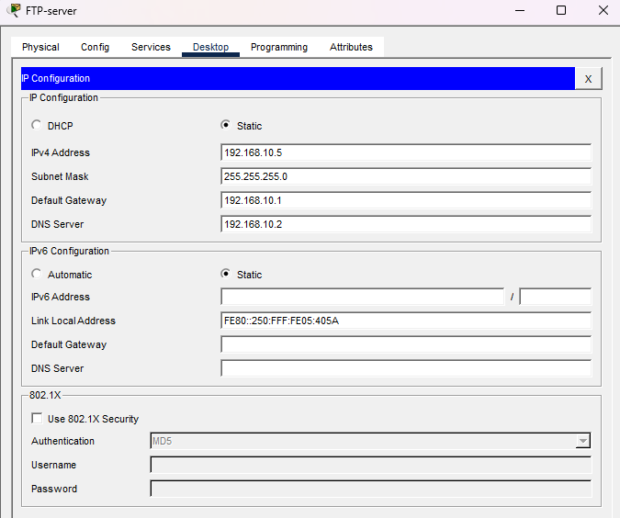
Fig 6 — FTP-server IP configuration — 192.168.10.5 /24, gateway 192.168.10.1

CHAPTER 5: TESTING, SCREENSHOTS & RESULTS

5.1 Connectivity Testing
End-to-end reachability between the Head Office and both branches was verified so that every host could ping across sites and reach the Head-Office-hosted services, confirming that the hub-and-spoke routing design was functioning correctly.

5.2 Branch IP Configuration Verification
The static addressing applied at each branch was verified directly on the end devices, confirming each PC held the correct IP address, subnet mask, gateway and DNS server for its site.
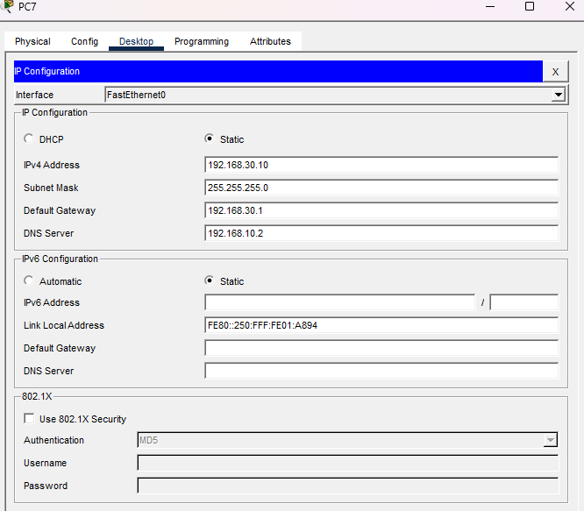
Fig 3 — Static IP configuration on PC7 (Branch 2) — 192.168.30.10 /24, gateway 192.168.30.1, DNS 192.168.10.2

5.3 Mail Service Testing
Email exchange across sites was tested using the built-in Mail Browser on a Branch 2 PC. Mail was successfully retrieved from the Head-Office POP3 server (192.168.10.4), including a message sent from a Branch 1 user (br1pc1@banking.com), confirming that the centralized mail service is reachable from every branch.
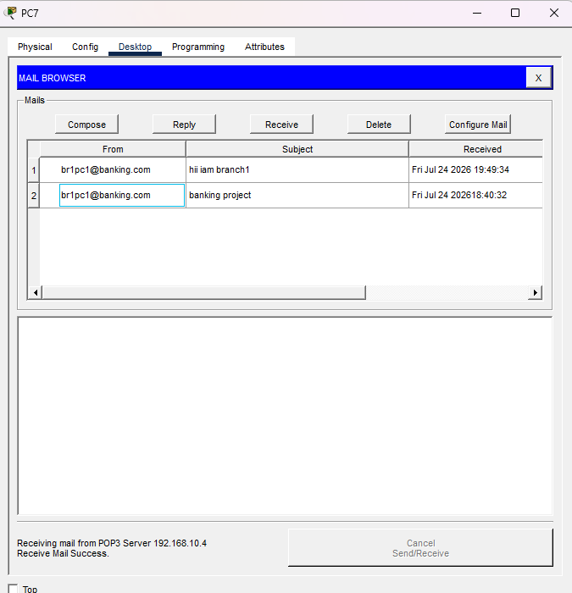
Fig 7 — Mail Browser on PC7 — mail successfully received from POP3 server 192.168.10.4, sent by br1pc1@banking.com

5.4 Web Service Testing
The internal "SecureBank" banking portal, hosted on the Head-Office Web-Server (192.168.10.3), was accessed from a Branch 1 PC using the built-in Web Browser. The page loaded successfully, confirming that HTTP traffic from the branch is correctly routed to the Head Office.
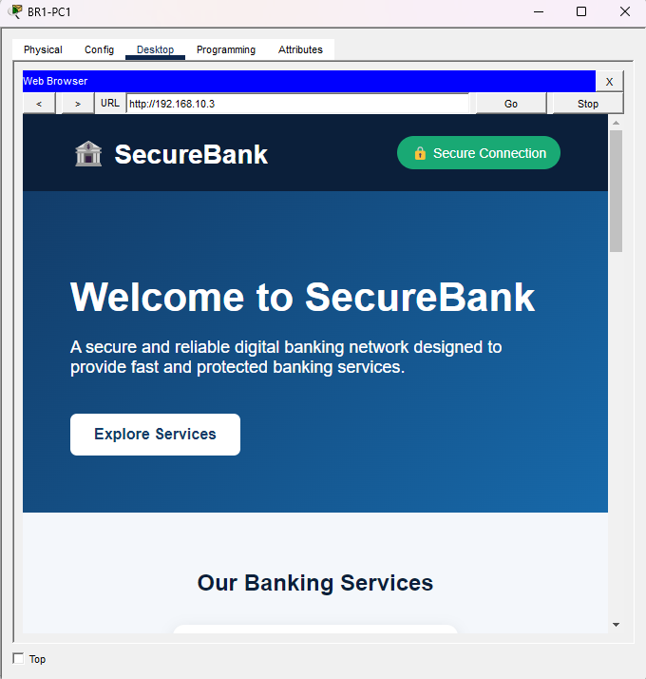
Fig 8 — Secure Bank web portal (http://192.168.10.3) accessed successfully from a Branch 1 PC

5.5 DNS Resolution Testing
Since every end device across the three sites is configured with 192.168.10.2 as its DNS server, branch PCs were able to resolve the hostname www.banking.local to the Web-Server's IP address 192.168.10.3 (Fig 5), confirming that centralized name resolution is functioning correctly for the whole bank network.

5.6 FTP Service Testing
FTP access to the Head-Office FTP-server (192.168.10.5) was tested from PC7 at Branch 2 using the Command Prompt. The FTP session connected successfully, the admin credentials were accepted, and the client logged in with passive mode enabled, confirming that centralized file-transfer access is reachable from a remote branch.
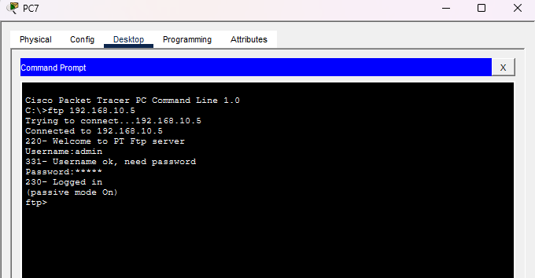
Fig 9 — FTP service verified from PC7 (Branch 2) — successful connection and login to FTP-server 192.168.10.5

5.7 Results
- All three sites (Head Office, Branch 1, Branch 2) successfully communicate with one another.
- Every branch PC correctly resolves and reaches the Head-Office-hosted web portal.
- Cross-branch email exchange through the centralized Mail Server works as expected.
- Centralized DNS resolution (www.banking.local → 192.168.10.3) is functional for all sites.
- Branch users can successfully authenticate and connect to the centralized FTP server.

CHAPTER 6: CHALLENGES & LEARNING OUTCOMES

6.1 Challenges Faced
Addressing Planning
Keeping the Head Office, Branch 1 and Branch 2 subnets non-overlapping while still allowing every site to route to the Head-Office server farm required careful up-front IP planning before any device was configured.
Service Reachability
Initial testing showed branch PCs could not resolve or reach the Head-Office web and mail services until the DNS server address and default gateway were correctly set on every end device, highlighting how a single misconfigured field can silently break an otherwise correctly routed network.
FTP Authentication
Verifying FTP access from a branch PC required confirming that valid credentials and passive-mode settings were used, since an incorrect username or password on the client would silently fail the connection rather than reach the server.

6.2 Learning Outcomes
- Practical understanding of designing a multi-site (hub-and-spoke) enterprise network.
- Hands-on experience assigning and verifying structured, site-wise IP addressing.
- Working knowledge of hosting and testing DNS, HTTP, Mail, FTP and Syslog services in Packet Tracer.
- Improved ability to systematically verify a network using built-in client utilities (IP Configuration, Web Browser, Mail Browser, Command Line FTP client).
- Better appreciation of how centralized services in a Head Office affect design decisions for remote branches.

CHAPTER 7: CONCLUSION & FUTURE SCOPE

7.1 Conclusion
The Secure Bank project successfully demonstrates the design, configuration and verification of a realistic multi-site banking network in Cisco Packet Tracer. A Head Office and two Branch Offices were interconnected in a hub-and-spoke topology, each site was assigned a clean, non-overlapping IP addressing scheme, and centralized DNS, Web, Mail, FTP and Syslog services were hosted at the Head Office and successfully accessed from both branches. Testing confirmed reliable connectivity, correct DNS resolution, working cross-branch email, successful FTP file-transfer access, and successful access to the internal banking portal from a remote branch — meeting all the objectives set out at the start of the project.

7.2 Future Scope
- Introduce VLAN segmentation within each site (e.g. separating Admin, Accounts and Manager traffic).
- Add Access Control Lists (ACLs) to restrict which branch hosts may reach sensitive HQ servers.
- Implement NAT/PAT for shared external internet access from each branch.
- Add a backup/secondary WAN link for redundancy between the Head Office and each branch.
- Extend the design with dynamic routing protocols (OSPF/EIGRP) for easier scalability to additional branches.
- Secure the FTP and Mail services further with stronger authentication and encrypted transfer (FTPS/SFTP).

REFERENCES
- Cisco Networking Academy — Introduction to Networks (CCNA v7).
- Cisco Packet Tracer — Official User Guide, Cisco Systems Inc.
- Todd Lammle, "CCNA Routing and Switching Study Guide," Sybex.
- Cisco Systems — IOS Command Reference Documentation, cisco.com.

